**Google Calendar widget**

**Manual Installation**

1. Copy **com.temenos.widgets.google_calendar** folder in your widgets folder (Ex: /{your project/templates/widgets/ }). Do not overwrite the **widgets.xml** from {**your project**} folder with the one provided in the widget folder.
2. Restart IDE.

**Auto-Installation**

1. Run IDE.
2. Go into the **Tools menu** -> **Options**, **Auto-install** tab and set the **Download Location** to the folder where you want to copy the widget.
3. Make sure the “**Switch Monitor on/off**” is checked.
4. Download/ Copy the widget (**com.temenos.widgets.google_calendar.zip**) to monitored folder (make sure to remove the **sample** folder from the **.zip** file).

No need to restart IDE.

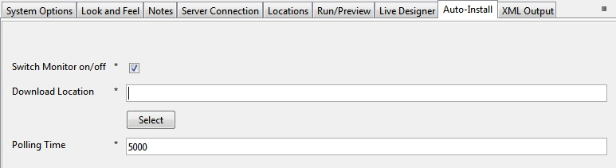

**Overview**

The **Google Calendar** widget allows a user to add an event to his Google Calendar. If the user it’s already logged in to his Google account he will not be prompted to login otherwise a pop-up will appear that prompt’s the user to login.

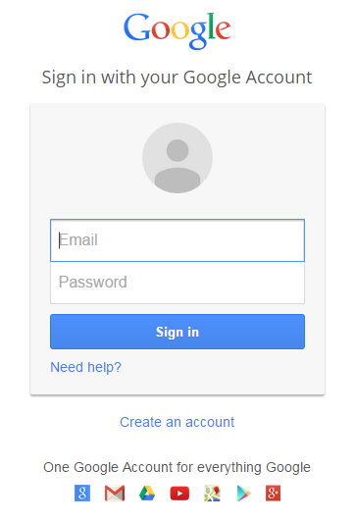

**Requirements**

For the widget to work we must use or create input fields from our project. The questions needed to make the widget work are:

* **Event name (Question – Data type** – Data item**)**;
* **Description (Question – Data type** – Data item**)**;
* **Start Date (Date** – **Data Type** with the default presentation format **dd/mm/yyyy)**;
* **Start Time (List – Data Type** import **GoogleCalendarHours.csv** from the folder **Lists** in the widgets main folder**)**;
* **End Date (Date** – **Data Type** with the default presentation format **dd/mm/yyyy)**;
* **End Time (Date – Data Type** import **GoogleCalendarHours.csv** from the folder **Lists** in the widgets main folder**)**;
* **Frequency (List – Data Type** import **Frequency.csv** from the folder **Lists** in the widgets main folder)
* **Until Date (Date** – **Data Type** with the default presentation format **dd/mm/yyyy)**;
* **Until Time (Data Type** import **GoogleCalendarHours.csv** from the folder **Lists** in the widgets main folder**)**.

They don’t need to have the same name but they must have the same data type and format

**Setup**

1. Before creating the **Google Calendar Button**, you have to create (if they are not already created) the fields required. The **Start Date** and **Start Time** must be set as required fields.

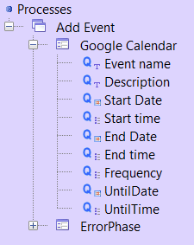

1. After that right click on **Google Calendar** Phase and add a button in the **Processes Editor**;

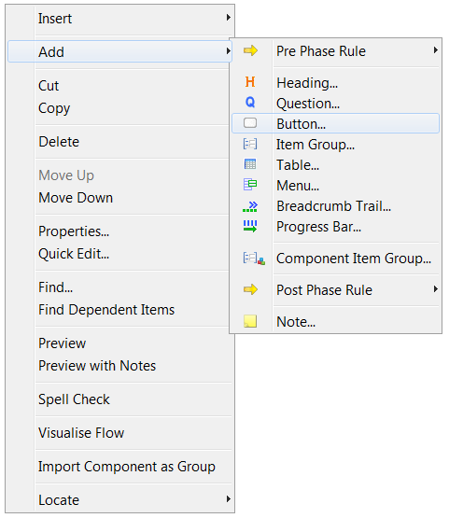

1. Name the button **Google Calendar** in the **Action Command** field and check if **Save Data to Data Store** and **Mandatory Fields** checkboxes are checked;

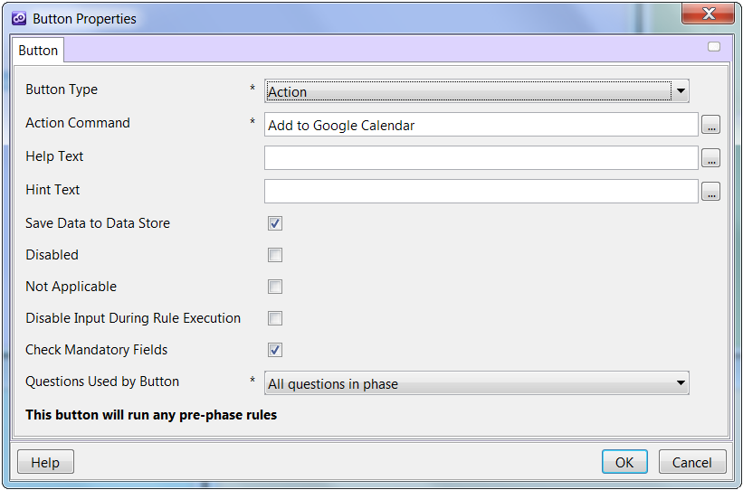

1. In the **Presentation Editor**, right click on **Google Calendar** button and click **Properties**;
2. In the buttons **Properties** manager go to **Widget Details**, click and select the corresponding items from the **Data Store**;

